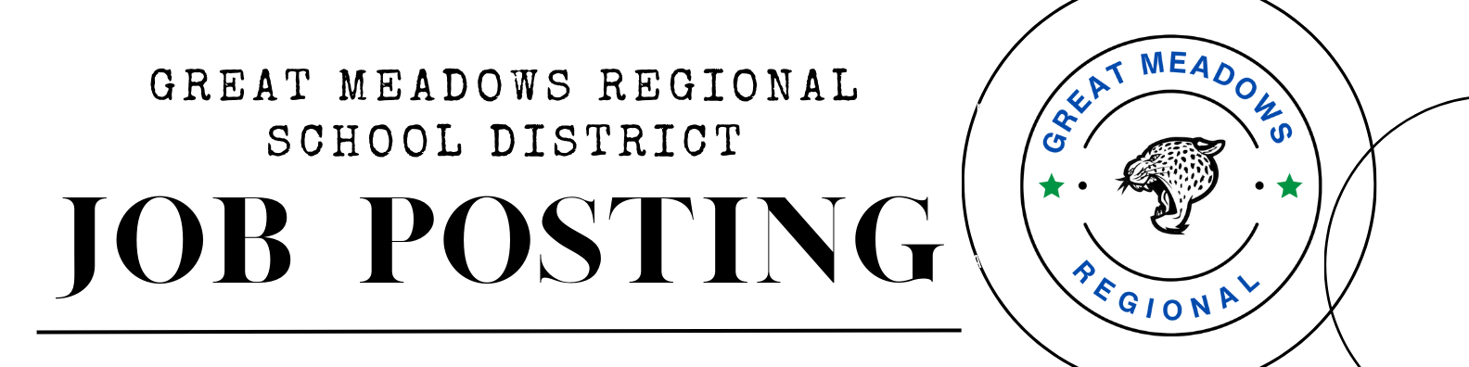

Great Meadows Regional School District – Warren County, NJ is looking to fill the following positions for the 2025-2026 school year:

TEACHING:
*PRESCHOOL TEACHERS (2)
*KINDERGARTEN TEACHER (1)
*2ND GRADE TEACHER (1)
*4TH GRADE TEACHER (1)
*K-3 EMOTIONAL REGULATION IMPAIRMENT (ERI) TEACHER (1)
Gr. 4-8 MIDDLE SCHOOL PHYSICAL EDUCATION TEACHER (1)
*Gr. 7-8 MIDDLE SCHOOL SCIENCE TEACHER (1)
*LANGUAGE ARTS/MATH INTERVENTION TEACHER (1)

MISCELLANEOUS:
SCHOOL COUNSELOR (1)
PART-TIME SPEECH THERAPIST (1)
PART-TIME BEHAVIORIST (1)

Expected Date/s of Assignment: August 27, 2025 – June 30, 2026

Qualifications/Requirements: NJ Grade Level and/or Subject Area Certification
*NJ Special Education Certification, preferred
Strong reading/language background
Knowledge of NJSLS
Proven ability to work collaboratively
Chapter #116 Security Clearance
Compensation: As per negotiated contract between GMRBOE/GMREA

Submit a letter of application, certificate/s, and resume to:

Michael Mai, Superintendent of Schools
Great Meadows Regional School District
PO Box 74
Great Meadows, NJ 07838
mmai@gmrsd.com

Deadline: May 23, 2025

